ESSAY ONE.
Five Design Works.

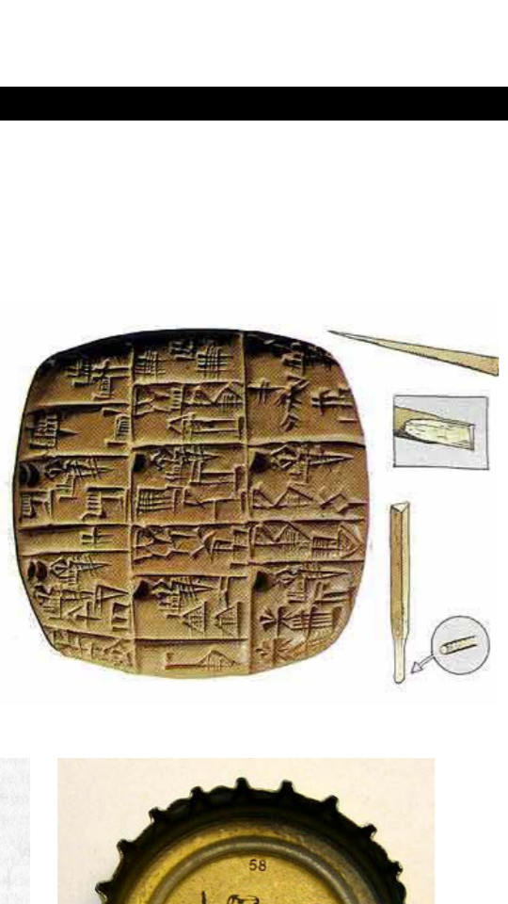
Cuneiform, (3200 BCE – 200 CE)
This work originates from Sumer or present-day Iraq. It began as a system of symbols that depicted ideas or objects present at the time. Cuneiforms involved a sort of wedge-shaped writings or marks recorded on clay tablets. The marks got put down using blunt reeds. This work inspires me because even with the fact that it is ancient, it had a staggering number of characters, 400 to be exact. The characters included consonants, syllables, and whole words that are also part of the modern language.

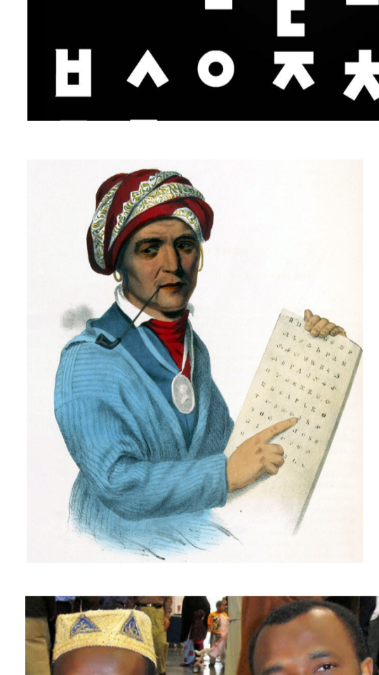
Sequoyah, Cherokee writing system, 1821
This was and is a writing system invented by Sequoyah, a Cherokee Indian, in the 18th century. He was a silversmith and a blacksmith, with a knack for writing. He possessed no English literacy. Hence, the writing system was for the Cherokee people. This work inspires me because after the Cherokee alphabet was invented, it went on to inspire a lot of scripts for many languages in Asia, North-America, and Africa.

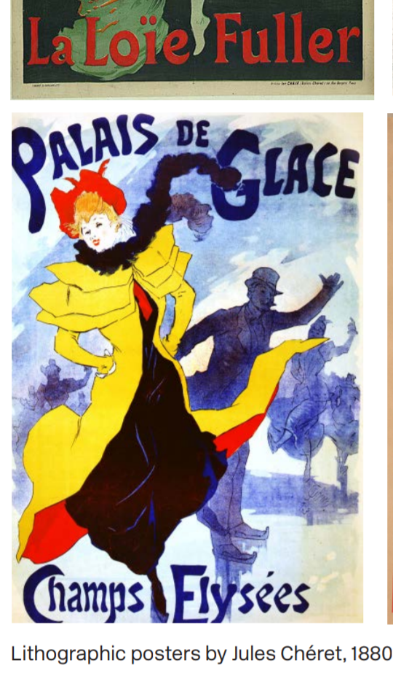
Jules Cheret, Cherette posters, 1880s – 90s
Jules was a lithographer who made a lot of lithographic posters in the 1880s and 90s that depicted life in Paris. His posters mainly included ‘Cherettes’ or young, urban women who were not void of moral, but also liked to have fun. This work inspires me because the lettering was hand drawn and with just three transparent ink colors, his posters looked fantastically done. He also gave the posters life through his suggestive art.

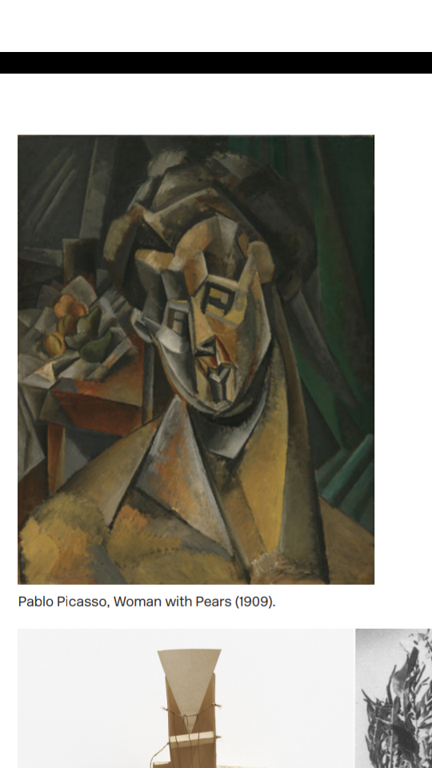
Pablo Picasso, Cubism, 1907
Pablo Picasso began this work in the beginning of the 20th century. It involved breaking down visual forms into abstracted planes. Cubism was meant to simultaneously depict objects from different perspectives. Its basis was African art. Picasso used this art to question Western tradition and the colonial violence is shown by the French at the time. This work inspires me because it inspired numerous movements that used it as their primary basis.
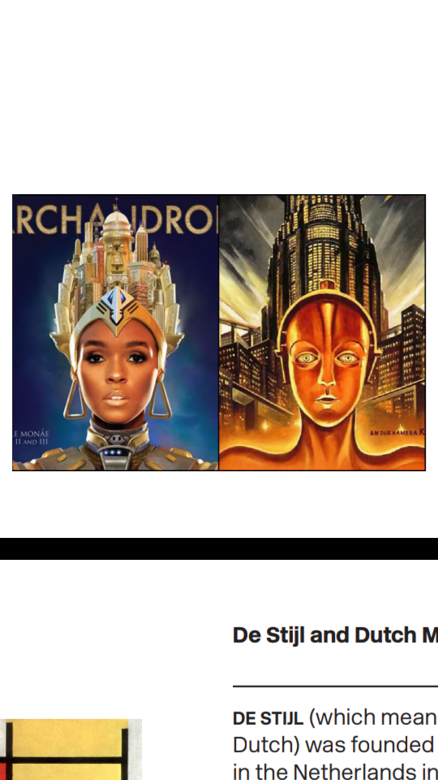
Janae Monelle, Feminism and Afrofuturism, 2010s
Janelle is an artist in the 21st century who incorporates visual styles that are meant to engage feminism and Afro-futurism. Her music and video depict a world termed as Wondal that involves classes of oppressed androids. This work inspires me because it tries to explain that oppression will always be present in society regardless of the race or nature of the people involved.

ESSAY TWO.
Visual Analysis: Diamond Sutra, China, 868 C.E; Gutenberg Bible, Germany, c. 1455.

Diamond Sutra, China, was and is, a Buddhist sutra from the ‘Perfection of Wisdom’ genre. It is centered on practicing non-abiding and non-attachment. The Sutra is a significant object used in devotion and study in Zen Buddhism. The book was translated into Chinese in 401CE on wood prints, with the main themes or focus being on anatman, the emptiness of all phenomena, and liberation of all beings without attachment, among others. A select number of Buddhist philosophers, translated the book.

Johann Gutenberg was responsible for inventing the movable-type printing press. The Gutenberg Bible was printed in Mainz, Germany, and is considered the first book to get printed. It was written in Latin. The Bible had two volumes, with three hundred words each. Gutenberg, at that period, was not recognized for the invention.

Both books are literary jewels. They both demonstrate the beliefs of religions, although different from one another. The Gutenberg Bible was printed on metal prints while the Diamond Sutra was written on rectangular woodblock prints.

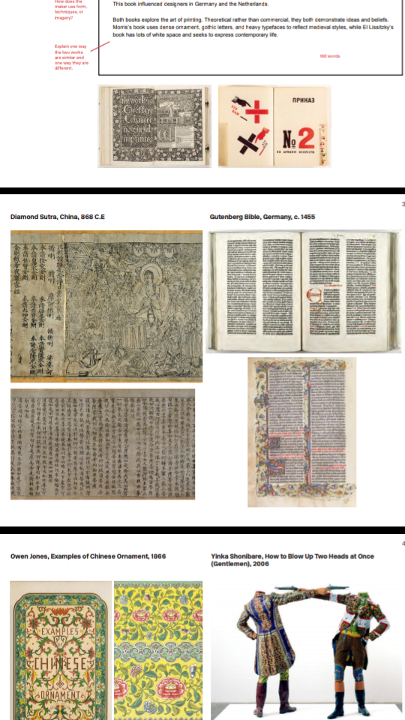

ESSAY THREE.
Hugo Ball`s Dada Manifesto (1909) vs Laszio Moholy-Nagy, The New Typography (1923)

Ball wrote the Dada manifesto in 1909. He was fascinated with the word Dada, which he termed as an international phenomenon, due to its many meanings. He viewed the word as easy to understand, and that for one to attain eternal bliss, or become famous, they should say dada. Ball viewed Dada as a symbol for everything, including people. Be it war, revolution, happiness, and historical figures. And that all of them were simply, Dada.

Laszio wrote the New Typography in 1923. He believed typography is integral in communication, and that it is in awe when communicated intensely. Laszio believed that typography, especially photography liberated readers who were receptive from the hold of an author`s own quirks, and urges them to create their own opinions of things. Laszio viewed typography as a crucial tool to empower people`s minds and make them think for themselves.

The manifestos are similar in their concept of psychological indulgence. They both are pushing for people to comprehend who they are, and thinking between the lines. Ball`s manifesto bases the word, Dada, as the reason for psychological questioning, while Laszio`s manifesto bases typography as the key to psychological freedom.

